**CHRISTMAS PROGRAM**

**United Presbyterian Church**

**December 24, 2024**

**6:00pm**

**Prelude Laura Van Meeteren & Wanda Brands**

**Lighting of the Advent Candles Gary & Angie**

**Diekevers family**

**\*Processional Hymn “O Come All Ye Faithful” 145**

**The Tiny Bells of Christmas Preschool – 2nd Grade**

**Ella Diekevers, Oliver Schmith, Catarina Morales, Maverick Schmith, Bryant Schafer, Colton Diekevers, Annie Starkenburg, Cheyenne Pedersen**

**“Ring the Bells” Preschool – 2nd Grade**

**“Go Tell It On the Mountain” Children’s Choir**

**Blessings 3rd - 5th Grade**

**Olivia Pedersen, Hudsyn Doorenbos,**

**Tanner Diekevers, Clayton Starkenburg**

**“Jesus Loves Me” Children’s Choir**

**Offertory Prayer & Offering**

**\*Offering to benefit the Sunday School**

**Still Life Nativity**

**Mary: Annie Starkenburg**

**Joseph: Clayton Starkenburg**

**Shepherds: Bryant Schafer, Maverick Schmith**

**Angels: Olivia Pedersen, Hudsyn Doorenbos,**

**Cheyenne Pedersen, Ella Diekevers**

**Wisemen: Tanner Diekevers, Colton Diekevers,**

**Oliver Schmith**

**King Herrod: Jake Pedersen**

**Narrators: Taelyn Doorenbos, Whitley Diekevers,**

**Lane Moret**

**“Away In A Manger” Children’s Choir**

**Congregational Hymn**

**“Angels We Have Heard on High” (vs 1 & 3) 132**

**Special Music “O Holy Night” Hannah Moret**

**Closing Hymn “Silent Night” 147**

**(sung by candlelight)**

**\*\*\*\*\*\*\***

The Christmas Program Committee would like to thank all who helped in any way with our program.

Bags of candy will be available for children in the narthex.

**The Christmas Story**

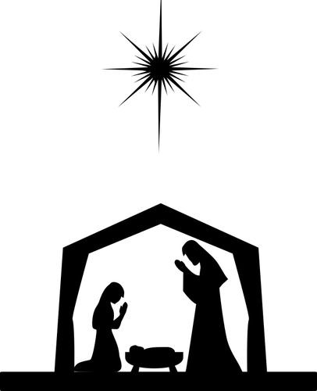

**CHRISTMAS EVE**

**2024**

**United Presbyterian Church**

**Boyden, Iowa**